**3 - ServiceNow User Interface Overview**

The User Interface of ServiceNow has two components -

* Banner
* Content frame

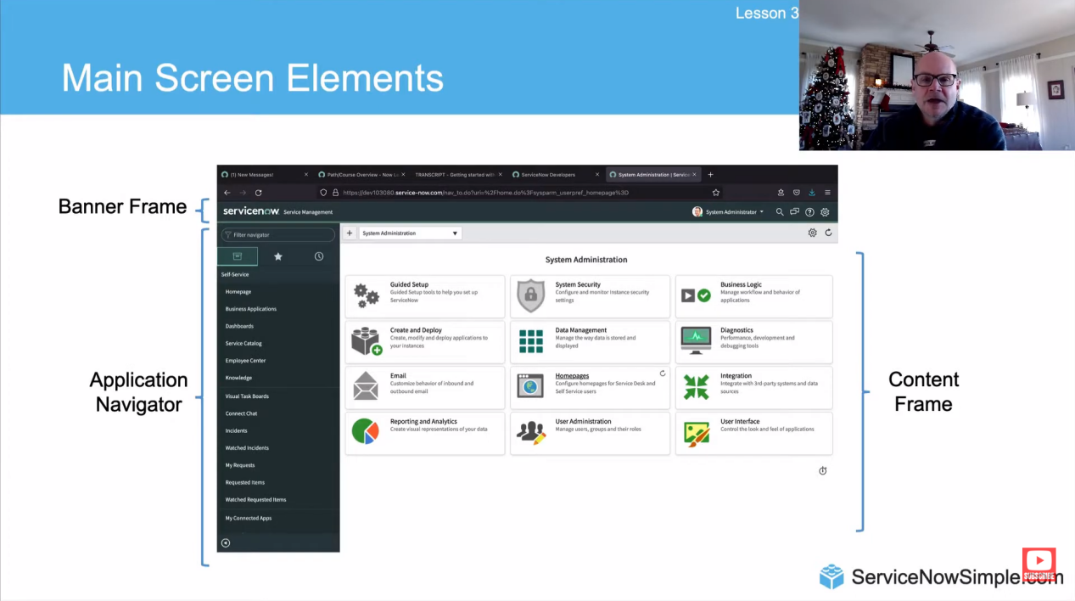

The **banner** runs across the top of every page. It includes a logo, navigation menus, the page title, global search, help, notifications, and a user menu.

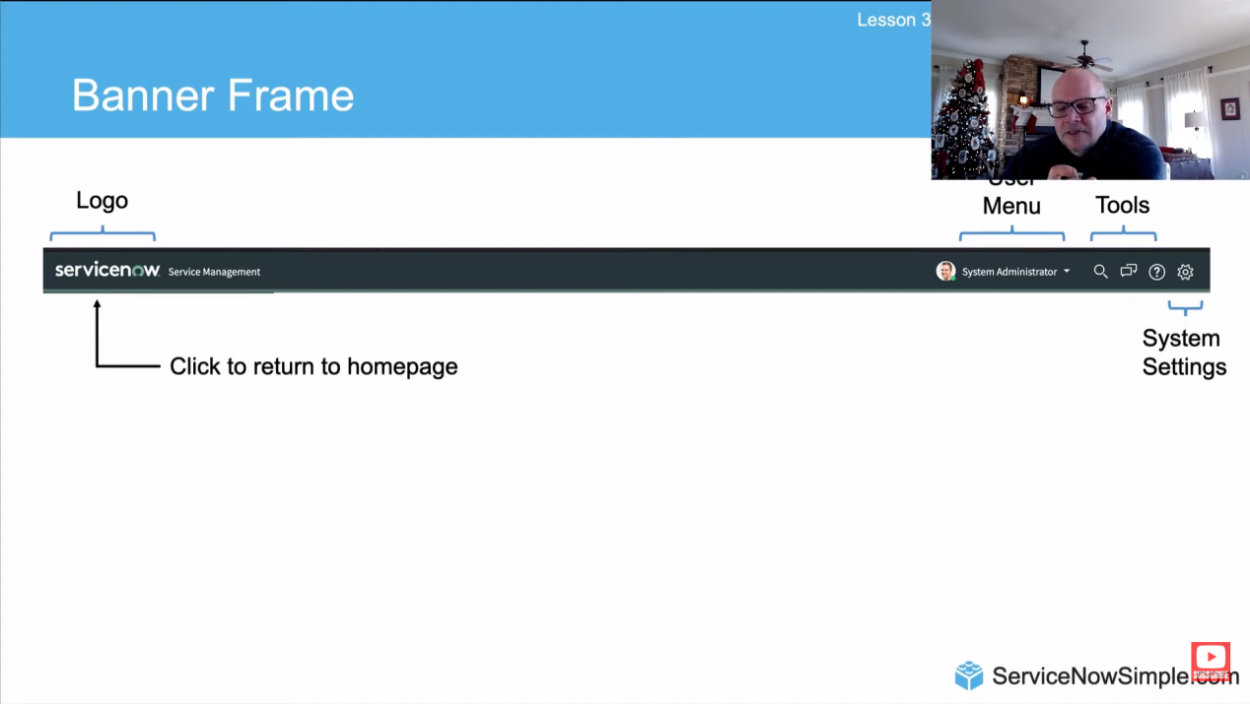

**Global Search -** It lets you find items that match your search term. By default, the results can include -

Cases

Customers or Users

ServiceNow Community Questions

Incidents

Change Requests

Problems

Knowledge Articles

To search, click on the search icon and type your term in the search field.



**Connect Chat -** Connect Chat is a real-time messaging tool that allows users to chat with individuals and groups, quickly share files, and collaborate on any record by instantly connecting with the right people. (Note : Connect Chat is not available in Next Experience. Starting with Washington DC, some Connect Chat functions are available in Next Experience using the Sidebar). Connect Chat enhances communication around records, Visual Task Boards, topics of interest, or groups. Features include-

Direct conversations between two users.

Group conversations with three or more users.

Conversations linked to records, where comments and work

notes appear in real-time, and users can update the record directly from the conversation.

Drag-and-drop sharing of links, files, and records.

**Contextual Help -** The ServiceNow system offers several preconfigured help contexts linked to specific information for the current list, form, or record. You can define custom help topics, which appear when users click the help icon in a ServiceNow record. By default, users click the help icon to access help pages provided in the base system. If no context-sensitive help is defined for a page, the help system's welcome page is displayed. Users can then use the search feature or index to find the right help topic. The help icon's location varies depending on the user interface version.

**Application Navigator -** The Application Navigator is on the left side of the interface and gives access to all applications, modules, favorites, and recently viewed items. It's used to quickly find information and services. It includes a navigation filter and these tabs -

All Applications - Shows all application menus and modules. Each application is listed as a section with an application label, and modules are listed by name under each label.

Favorites - Shows items you've marked as favorites.

History - Shows items you've recently accessed.

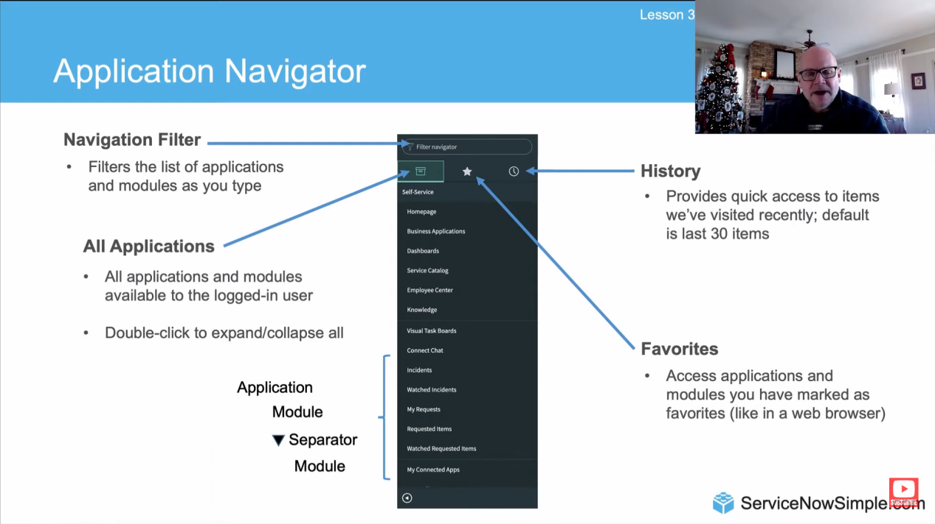

**ACLs -** Each row in an access control list (ACL) represents a specific rule. The number (#) indicates the order in which these ACLs are checked. At the table level, ACLs only evaluate roles and security attributes; conditions and scripts are not considered. ACLs control data access by requiring users to meet certain conditions before interacting with the data.

**UI Policies -** UI policies adjust how information behaves on a form and manage custom process flows for tasks. For example, UI policies can make a number field read-only, require a short description, or hide other fields. Basic UI policies don’t need scripting, but for more complex actions, you must use the Run scripts option. While client scripts can achieve similar results, UI policies are preferred for faster load times.

**Client Scripts for UI Policies -** Any scripts can be created for UI policies to run on the client side. We can use different options in the UI Policy form to control when and how the UI policy is applied. These options include client scripts, OnLoad execution, and view-specific UI policies. Administrators can use the UI Policy form to create client scripts that run onChange when the UI policy conditions are met (*Execute if true*) or not met (*Execute if false*). To display these scripting fields in the UI Policy form, in the Script section, select the *Run scripts* check box.

**Business Rules -** A business rule is a server-side script that runs when a record is shown, added, updated, deleted, or when a table is queried. These rules execute based on specific server-side conditions and determine when to run relative to database operations and which record operations they affect. For client-side conditions, there are other scripting options available, such as client scripts and UI actions.

**Client Scripting -** Client scripts run JavaScript on the web browser in response to events like form loading, form submission, or field value changes.

ANANYA CHOUDHARY